Introduction

Have you ever met someone who said…

"I should have traveled more when I was younger”? Or have you met a couple who had the dream to retire and travel together, only to encounter health issues that prevented them from doing so?

We didn't want this to happen to us.

About 10 years ago we started thinking about traveling sooner rather than later; and not just for a two-week break, but a whole year. Our Goal: Travel to new places, eat weird foods, and attempt to learn exotic languages. Strive to live like the locals and experience the world by going beyond “vacationing” to immerse ourselves in unfamiliar cultures.

Modest beginnings.

We grew up lacking opportunities to travel much beyond our backyards with the exception of a few scouting and school field-trips to nearby states. Matt traveled some while serving in the US Air Force, but knew that there was much more yet to experience.

We met in 1999 and started expanding our travels by taking road trips in the United States. Then we secured our passports and traveled to Mexico and the Caribbean, places that were easy to get to with limited vacation time. Last year, we finally booked a 2-week journey to visit 3 different cities in France. Bon…Très Bon!

Our plan started to take shape.

We worked towards our goal by starting out slowly. We knew we wanted to travel, but for how long? Where? How much money would we need? And more importantly, with all these looming questions, where do we start?

This guide depicts how we turned our dream into reality.

We hope that you can take something from this and practically apply it, whatever your dream. Enjoy!

Your Travel Goal

So, what is your goal? Whatever it is, it should be S.M.A.R.T.

Our suggestion is to start with something to aim at - A goal. It's great to have a goal "to travel", but do you know what you want to accomplish with your travels? Is it to help others? Learn more about the world? Perhaps you want to check something off of your Bucket List? Also, when do you want to accomplish the goal? Within the next six months? Five years? 10 years?

Similar to setting goals at work, personal goals need to be S.M.A.R.T.

Each goal you set for yourself needs to be:

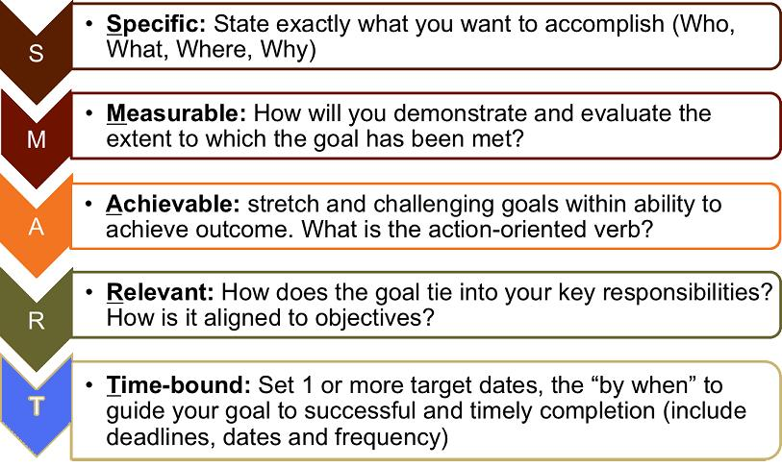

Reaching your goal can take time. Stay inspired.

Tell your friends, family, and co-workers; find ways to keep your long-term goal visible. We told anyone who would listen about our intentions to travel. What ended up occurring was amazing! Others started sharing their travel stories, favorite sites, lodging options, restaurants, and more. Each of these discussions inspired us. It motivated us to document our travel ideas, purchase books, magazines, movies, and research potential destinations on the Internet. More importantly, it kept us talking about our travel goals and the necessary steps to recognize them.

The Devil’s in the Details

Identify realistic objectives.

Creating a travel goal is not enough. Similar to many things in life, there are necessary preparations for taking extended time off from "normal life". Begin by identifying realistic objectives. We established yearly financial, personal, travel, and other objectives. The many objectives we pursued in preparation to reach our end goal, turned into mini (short-term) goals themselves.

1) Brainstorm – Identifying the necessary objectives to reach your long-term goal can be daunting, so we suggest you brainstorm ideas first, perhaps over a tasty libation. Discuss what needs to be done to make your travel goal a reality. Write these rough ideas down on scratch paper. Remember, there are no bad ideas while brainstorming - This is the time to let the thoughts flow freely; discussion, dissection, and further analysis can wait for the next step.

2) Organize – Review your objectives and consider how they fit into different categories for organization purposes.

3) Publish – Discussing and writing down your objectives is a solid start, but if you to put the list out of sight it will likely fall out of mind. Placing your objectives somewhere public reduces the likelihood of cheating and increases potential for achievement.

We distilled our annual objectives on a marker-board to offer a visual sense of accomplishment – Each objective was crossed-off upon its completion. The list was freshly created on a yearly basis, and items that were not fully completed were carried over to the following year. If a whiteboard is not an option, type out your goal and objectives and publish them to the Internet, on the fridge, in your office, etc. The whole idea is to provide visibility.

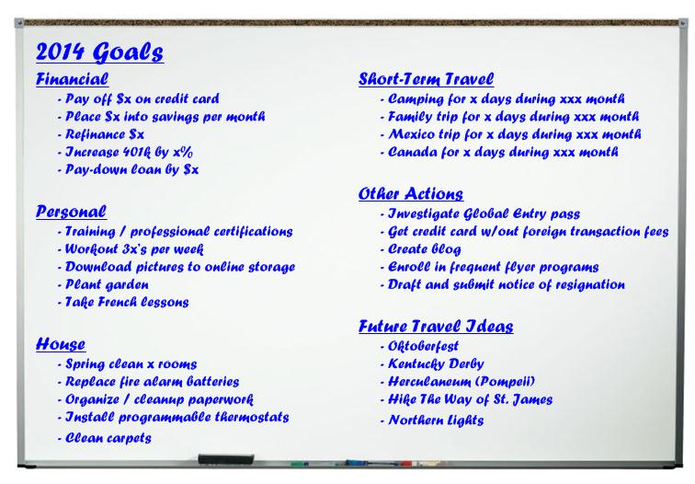

Cha-Ching! (Financial Prep)

Everything costs something.

Money is one of the biggest considerations when planning travel. How to Reach $1 Million (Money Magazine, 2012), offers a selection of basic money-saving insights. While the article was written with a specific target amount in mind, the same logic can be applied to funding a sabbatical. Below is a list of the article’s methods accompanied by a brief description of how we applied each.

1) Invest your way to riches – We established automated, recurring savings deposits. This method prevented the money from being available in our normal checking accounts where we may have been tempted to spend it. As our savings increased we gradually shifted our investments from mutual funds into less risky money market accounts to avoid an untimely reduction in value.

2) Be a real estate mogul – We purchased a modest condo in downtown Denver shortly after the real estate bubble burst. It was within walking distance of our offices and we were able to recognize a reasonable amount of equity when we sold it.

3) Launch a successful startup – Matt formed a one-person consulting firm one year prior to departure. Retaining money in the company positioned us to maintain a small income while traveling and also provides a path for subsidized insurance costs.

4) Be a super saver – As mentioned in the first point above, automated, recurring deposits were an important source of savings. As we progressed towards our goal, we intentionally increased the amount being set-aside. This was realized through raises, debt reduction, and budget streamlining efforts such as discontinued cable and home phone service.

5) Climb the corporate ladder – We have pursued opportunities for upward mobility at our various places of employment over the years. Increased responsibility was often accompanied by increased compensation which helped us accumulate our nest egg.

We experimented with multiple money-saving methods. No single approach proved sufficient on its own to position us for success. But collectively, the steps above provided the necessary accumulation to recognize our goal without sacrificing future security.

Small amounts add up.

People save in different ways. One nontraditional approach we followed for the past decade was to accumulate our spare change in two large glass containers. Cashing-in the change prior to our year-off netted several hundred dollars for deposit in our travel account. It’s not much, but it adds up to sponsor dinners and outings.

Financial Prep (Continued)

How much is enough.

The amount of money you save will depend upon several factors such as how long you would like to travel and what type of accommodations, food, and lifestyle you want to recognize while on the road. We assembled a Travel Planning Worksheet to track anticipated costs to maintain recurring expenses such as insurance and cell plans as well as travel-specific costs.

How to make sure it lasts.

We established a separate savings and checking account along with automated transfers between them to simulate traditional payroll. This establishes a set amount of money that must last until our next automatic transfer. Low cost destinations allow us to set-aside unspent funds for future spots with a higher cost of living.

Insurance costs.

Most traditional insurance companies do not extend coverage to overseas locations, so a supplemental travel insurance policy is highly recommended and can be sourced at a reasonable price. We researched this topic and recently identified a website that provides convenient side-by-side plan comparisons. Entering basic information at http://www.insuremytrip.com/ identified InsureAssist as a quality insurance provider to fulfill our needs.

Beyond international insurance, coverage adjustments may be required at home. We are maintaining our traditional health insurance in the United States since we will be back several times during our travels. Even if we were traveling outside of the country long-term, we would likely maintain this plan as it provides a safety net in the unlikely event of an emergency medical evacuation.

Our trip also provided an opportunity to reduce automobile coverage while away. Consult your insurance agent to find out what options and changes are recommended.

Tax considerations.

Taking a full year off from work sounds great, but paying taxes is part of life and should be considered. Will you generate sufficient income during your time off to benefit from the tax deductions you traditionally claim? Will you be at home during tax season or will you need to file an extension? Consult a tax professional for advice on how to handle these questions.

Carpe Diem! Create rewards for accomplishing key milestones.

It feels good to accomplish something significant and it’s appropriate to celebrate a job well done. Upon recognition of key objectives, it’s important to celebrate. Book an evening out at a favorite restaurant or a weekend get-away trip. Don’t wait to celebrate. Carpe Diem!

We are Going to Pump You Up (Physical Prep)

It is time for a little housekeeping.

Extended travel presents a perfect opportunity to ponder what possessions you may no longer need. In addition, the items you do keep may require organization and/or storage. We went room-by-room, cleaning each and identifying clothing, dishes, DVDs, etc. for donation. You may find value in selling your items on eBay, Craigslist, or having a yard sale to generate a little revenue for your trip.

Document management.

As with housekeeping, you may find that travel motivates the review of documentation you store. Perhaps it’s time to shred outdated paperwork. Consider scanning and storing critical content to an infrequently used email account or in 'the cloud’. Hard to replace artifacts may need to go into fire-safe storage or a safety deposit box.

In addition, organize necessary travel paperwork. This may include renewing passports and driver’s licenses, securing immunization cards, and managing your travel itineraries through websites such as TripIt or the FlightTrack cell phone application. Consider other ways to make travel easier by using Global Entry which can expedite clearance through customs and TSA.

The art of packing.

It is an art to pack efficiently and effectively. Virtually every travel book and website will encourage you to pack light to maintain mobility and flexibility. We agree with this approach and limit ourselves to what fits within two Osprey Meridian 22” wheeled-backpack carry-ons complemented by small shoulder-bags for computer and books. We created Travel Packing Lists for the types of trips we might take in an effort to help us pack efficiently.

If you haven't got your health, then you haven't got anything.

Remember to not only research your destinations, but also what vaccinations the CDC (Center for Disease Control and Prevention) recommends for your targeted itinerary.

In addition, before you travel outside of the United States, consider knocking-out those annual checkups with your dentist, eye doctor and General Practitioner (GP). When we discussed our travel plans with our GPs, they advised us to speak to a travel health expert at Global Travel Health at Rose Medical Center to understand the latest in vaccinations necessary for the destinations we would be visiting. Secure a card reflecting when your vaccinations were preformed, you may need it. We recommend you secure as many vaccinations and prescriptions as possible while you have an employer-subsidized insurance plan.

The Head and the Heart (Mental Prep)

Get smart!

While working towards a long-term travel goal it’s the perfect opportunity to research your destinations. Not only does this provide education, but it inspires and motivates. Read books, magazines, and internet sites/blogs. Also, talking to others about their travel experiences informed us of various locations to consider for our trip.

In addition, teach yourself how to speak another language. It’s always appreciated when you try to speak the local language, even if it’s not perfect. We have tried French, German and are currently diving into Spanish.

Safety first.

Being safe is always a priority. Use common sense while traveling – Consider referencing the Better Health Channel website for general safety considerations.

When we went to Global Health for our immunizations, they not only supplied us with our necessary shots, but also provided paperwork on each country we planned to visit. This documentation included information about local transportation, currency conversion, and safety considerations.

We saved the link of another helpful website, U.S. Department of State International Travel to our mobile phones, for convenient reference while we are traveling.

Adios! Saying goodbye.

Saying goodbye can be harder than you may think. Keep loved ones informed by maintaining contact so they know you are doing well and not to worry. We created our blog, which includes email and general web responses, so people can stay in-touch. In addition, we secured the Viber application which provides free calls and texting. Check with your mobile phone provider regarding international plan availability. It can be very expensive lesson (so we hear from friends).

If saying goodbye is difficult, remind yourself that this experience is not a good-bye, but a hello to a whole new chapter in life!

Always leave ‘em wanting more.

By no means is this everything we considered to reach our destination – a year off. We will continue to keep you informed of other discoveries and tidbits while we travel. Visit our website/blog and follow us at www.DINKSTravel.com to learn more.

We want to hear from you!

We are constantly learning through this process. Share your travel and goal setting experiences with us by emailing info@DINKSTravel.com.

